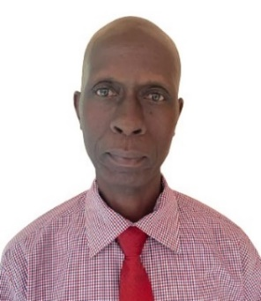
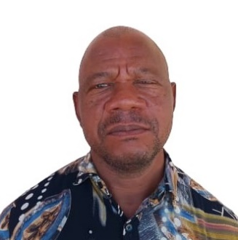
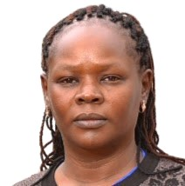
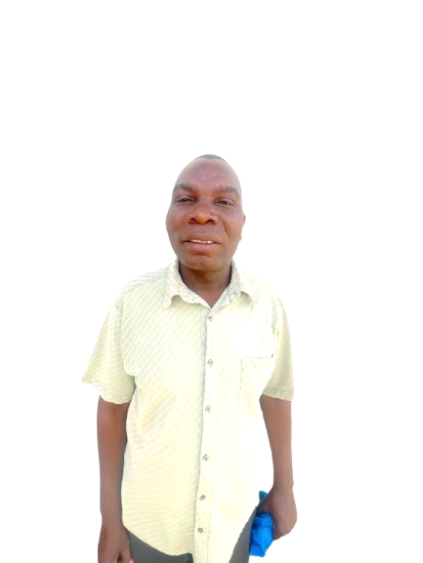
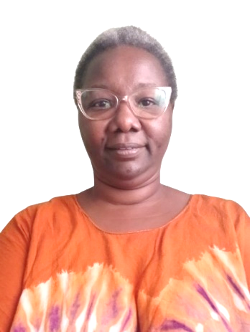
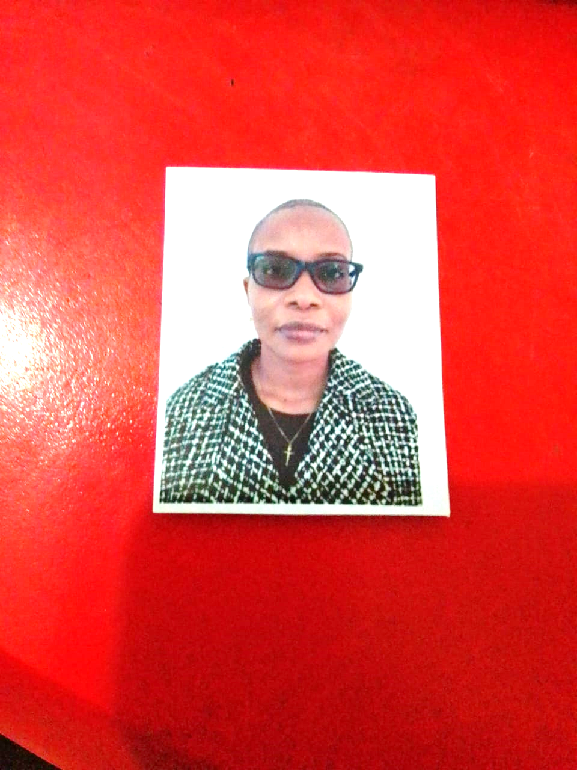
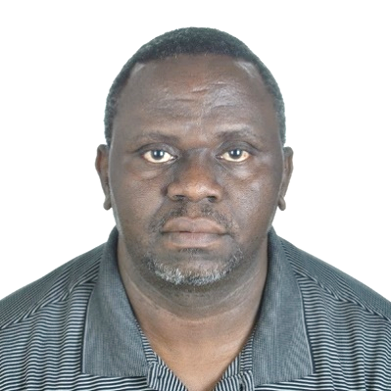
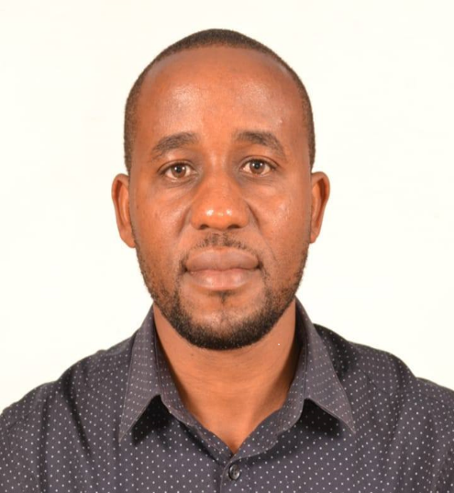
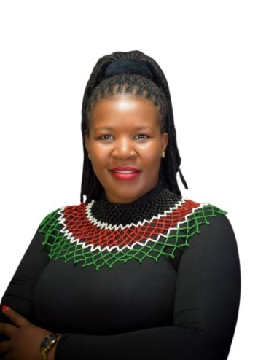
Joseph M. Mwengea - Secretary
Elias N. Tsuma - Treasurer
Eunice N. Kioko - Chairperson
Emmanuel M. Mwengi – Executive Member
Mike Mutua – Executive Member
Gloria M. Hope – Member
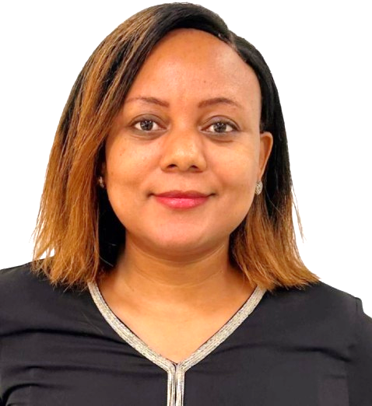
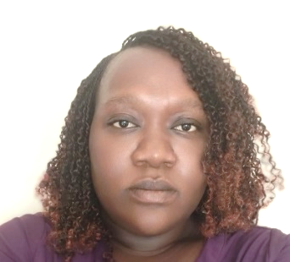
Raphael N Mangisi – Member
Marstela Tesha – Member
Alice N. Mwaka – Member

Linah M. Mjomba – Member
Luvuno Lung’anzi Chai – Member

